Facade design pattern

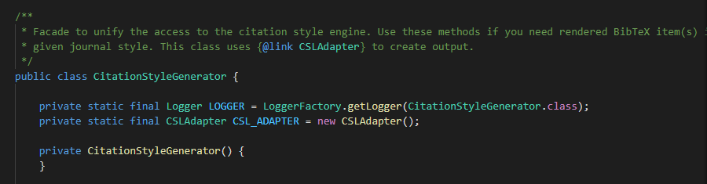

Esta classe encontra-se em src\main\java\org\jabref\logic\citationstyle\CitationStyleGenerator.java.

It is used to unify the access to the citation style engine.

